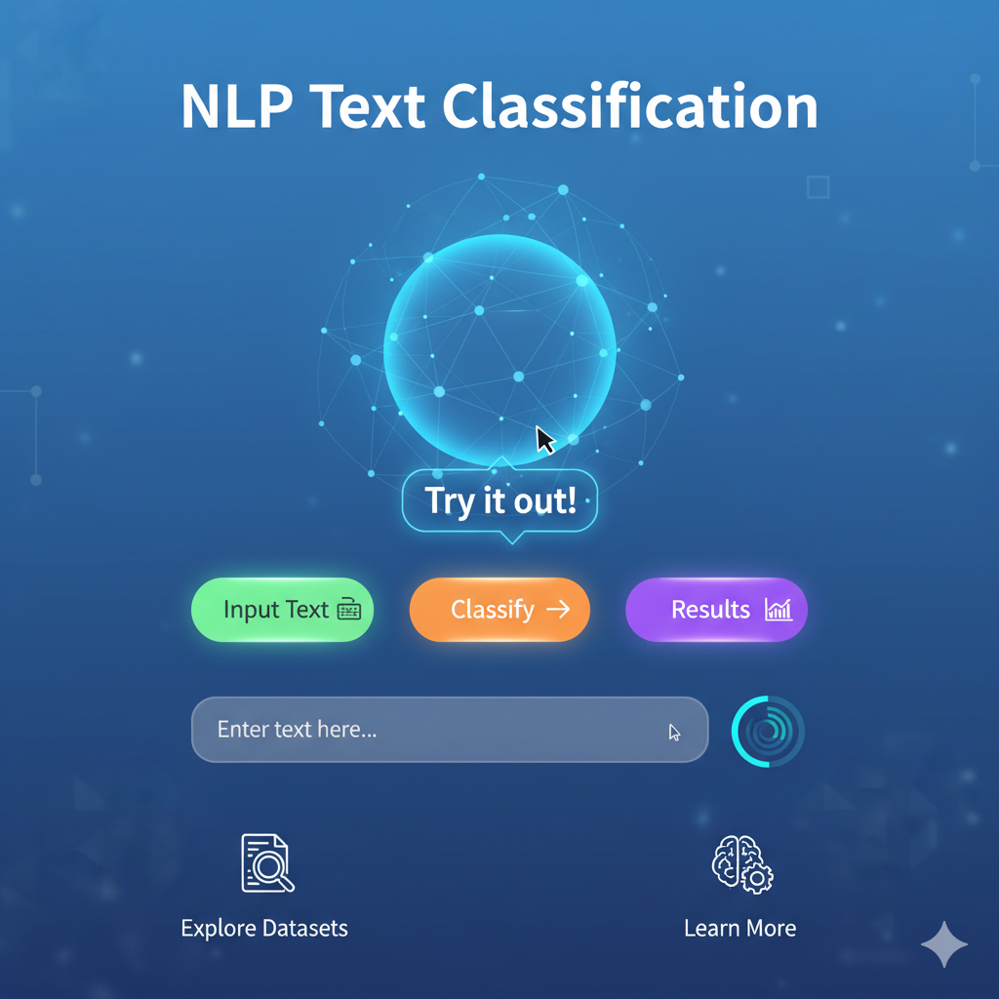

NLP Text Classification Project
-Complete Documentation

Project Overview
This project focuses on building an NLP-based text classification model that predicts the correct label for a given paragraph. The dataset contains training text, labels, and a test set for generating predictions.
The key steps include:
- Text preprocessing and noise removal
- Exploratory Data Analysis (EDA)
- TF-IDF text vectorization
- Training multiple machine learning models
- Model comparison & evaluation
- Error analysis
- Creating a FastAPI prediction service
- Dockerizing the entire application

Dataset Description
The dataset contains 4 files:
- train_data.csv
  - Columns: text, id
  - Contains input paragraphs.
- train_label.csv
  - Columns: id, label
  - Contains labels mapped using the id.
- test_data.csv
  - Only text and id
  - Predictions must be generated for this dataset.
- Sample_submission.csv
  - Format in which predictions must be submitted.

Data Loading & Merging
train_data = pd.read_csv("train_data.csv")
train_label = pd.read_csv("train_label.csv")
test_data = pd.read_csv("test_data.csv")
df = train_data.merge(train_label, on="id")

This gives a final training dataset containing:
- text
- label

Text Cleaning & Noise Removal
A custom text cleaning function was created to normalize the input text.
Cleaning steps include:
- Lowercasing
- Removing punctuation
- Removing URLs
- Removing numbers
- Removing HTML tags
- Fixing contractions
- Removing non-ASCII characters
- Removing extra whitespaces
def clean_text(text):
text = text.replace("\n", " ").strip()
text = contractions.fix(text)
text = re.sub(r'<[^>]+>', ' ', text)
text = re.sub(r'http\S+|www\.\S+', ' ', text)
text = re.sub(r'\d+', ' ', text)
text = re.sub(r'[^\x00-\x7f]', ' ', text)
text = re.sub(r'\s+', ' ', text).strip()
return text.lower()
Applied to both test and train data

Exploratory Data Analysis (EDA):

Label Distribution

Shows imbalance between classes.

Word Count Distribution
Helps understand text length spread.

WordCloud
Visualizes most frequent words.

Unigram, Bigram, Trigram Frequency
Shows important text patterns.

Word Count vs Label
Identifies if certain classes have longer texts.

Train-Test-Validate Split:
X = df["clean_text"]
y = df["label"]

X_train, X_valid, y_train, y_valid = train_test_split(
X, y, test_size=0.2, random_state=42, stratify=y
)

Feature Engineering using TF-IDF:
Both word-level and character-level TF-IDF were used for better performance.
tfidf = TfidfVectorizer(ngram_range=(1,2), max_features=20000)
X_train_tfidf = tfidf.fit_transform(X_train)
X_valid_tfidf = tfidf.transform(X_valid)
test_tfidf = tfidf.transform(test_data['clean_text'])

Model Training & Comparison :
The following machine learning models were trained:
- Logistic Regression
- Linear SVC
- Multinomial Naive Bayes
- Random Forest
Each model was evaluated on the validation set.
from sklearn.linear_model import LogisticRegression
log_reg = LogisticRegression(max_iter=300)
log_reg.fit(X_train_tfidf, y_train)
Similar code was used for other models.

Model Evaluation :
Metrics used:
- Accuracy
- Precision
- Recall
- F1-score
- Confusion Matrix
Example:
pred = log_reg.predict(X_valid_tfidf)
print(classification_report(y_valid, pred))

The best model achieved around 43% accuracy, and further improvements were explored.

Error Analysis :
A detailed error analysis section included:
- Misclassified samples
- Confusion matrix (raw & normalized)
- Per-class F1-score bar chart
- Common confusions between specific label pairs
- Top features causing errors
Misclassified examples were saved:
misclassified = valid_df[valid_df['true_label'] != valid_df['pred_label']]
misclassified.to_csv("misclassified_examples.csv", index=False)

This allowed us to understand patterns leading to wrong predictions.

Improvements Attempted :
To improve the accuracy, the following enhancements were tested:

Better text cleaning

TF-IDF word + character n-grams

Class balancing (class_weight='balanced')

Hyperparameter tuning (GridSearchCV)

Ensemble models (Stacking)

Predicting on Test Data:
Using the best model:
test_probs = best_model.predict_proba(test_tfidf)

The predictions were added to sample_submission.csv and saved:
submission.to_csv("final_submission.csv", index=False)

FastAPI Model Deployment:
A simple FastAPI service was created with:

/predict – single text prediction

/predict_batch – multiple text prediction
Key files:
- app.py
- clean_text.py
- model.pkl
- tfidf.pkl

Example (single prediction):
@app.post("/predict")
def predict(data: TextInput):
cleaned = clean_text(data.text)
vector = tfidf.transform([cleaned])
pred = model.predict(vector)[0]
return {
"input_text": data.text,
"cleaned_text": cleaned,
"predicted_label": str(pred)
}

Run Using:

uvicorn app:app --reload

API Available at:

http://127.0.0.1:8000/docs

Dockerization:

Dockerfile:

FROM python:3.11-slim
WORKDIR /app
COPY . /app
RUN pip install --no-cache-dir -r requirements.txt
EXPOSE 8000
CMD ["uvicorn", "app:app", "--host", "0.0.0.0", "--port", "8000"]

Build :
docker build -t nlp-fastapi .

Run:
docker run -p 8000:8000 nlp-fastapi

15. Key Learnings
- NLP tasks require good text preprocessing & cleaning.
- TF-IDF + classical ML works well with low-compute environments.
- Character n-grams help handle misspellings & noisy text.
- Error analysis is essential to understand model weaknesses.
- FastAPI + Docker provides an easy deployment workflow.

Conclusion
This project demonstrates the complete pipeline of an NLP text classification system:
- Data preprocessing
- Feature engineering
- Model training
- Evaluation and improvement
- API deployment
- Docker containerization
It creates a reusable machine learning workflow suitable for production environments.

